Airam Gonzalez
Aayesha Islam
Natalia Munetones Martinez
Dana Moreno
Gabriel Zardoya

December 6th, 2023

C&G Main Campus
123 Grinter Hall
PO Box 113001
Gainesville, FL 32611-3001

To the Office of Contracts and Grants,

On October 13, 2023, we received a Request for a Proposal from the University of Florida Office of Sponsored Research, funded by the US Department of commerce and US Department of Energy. The objective of the RFP is to stimulate new research opportunities associated with emerging technologies. Sponsorship is granted to projects that propose an innovative response to an economic, environmental, or social problem that is recurrent in society. There is a priority for proposals that aim to improve the quality of life of American citizens as well as American industry. Attached is the proposal that accomplishes the goals of the RFP.

With the increasing understanding of emerging technology, we can implement many of its aspects to aid us in our everyday lives. This concept is particularly important when considering higher level education, as accessibility to resources becomes a challenge to certain populations of students. For students with disabilities, there is a gap observed in the accessibility to accommodations. This gap often leads to unequal opportunities for success in academics when compared to their peers. Thus, making it increasingly difficult for students with disabilities to complete their academic goals such as completion of their degree. As a result, the need for a space that aims to provide equal opportunity of success to these student populations is imperative.

Our project proposes a mobile application that provides students with different features aimed at improving their performance in classes. We surveyed students from the University of Florida to gauge the need for the app, as well as receive interest from volunteers who will provide content for the app. The results revealed that there is interest among students for this app. Our plan includes an app that provides note taking lectures, speech to text captions, and audiobooks to the users, along with other aspects that participants expressed interest in. Additionally, we will be providing incentives to volunteers interested in providing content for the app. Overall, the implementation of the app is reflective of improving the quality of life for students at the University of Florida.

This mobile app contributes valuable features to the students at UF and can be further catered to students nationally and globally with sufficient support. Overall improving the numerous opportunities for students with disabilities as well as students in general. We can be contacted at (xxx) – xxx – xxxx. We look forward to hearing from you.

Sincerely,
Gonzalez, Islam, Martinez, Moreno, Zardoya

Airam Gonzalez, Aayesha Islam, Natalia Munetones Martinez, Dana Moreno, Gabriel Zardoya
December 6, 2023
444 Newell Dr. Gainesville, FL 32611
Mobile Application for Disability Accommodations and Academic Success

Executive Summary
Students suffering from disabilities have always had a harder time performing academically than their peers. For this reason, they are provided accommodations and resources to help them succeed in their studies so they can enjoy the same opportunities as any other student. However, even with all the progress that the education system has made regarding providing resources and helping students with disabilities to succeed academically, disabled students continue to lag behind their peers. This includes students who suffer from cognitive, psychological, and physical disabilities. Those suffering from cognitive disabilities are the most affected since their rates of bachelor's degree completion are significantly lower than that of their peers, most of them dropping out based on their first-year performance. The main reason for this trend is the fact that most students never register with their Disability Resource Center and many who do often do it only for one semester. Not registering to use the provided resources is highly prejudicial, as the use of disability accommodations is directly related to increases in GPA.
In today's rapidly evolving world, new technologies are constantly finding their way into all aspects of our lives, and education is no different. As such, this paper proposes the creation of a mobile application that can make academic resources more easily available and free of charge for all students, but specifically for students with disabilities. The app will contain resources such as class notes and speech-to-text captions. These will be provided to the app by other students, who will be rewarded for their assistance. The approximate initial cost will be $200000, and an additional $25000 each year to maintain the app and compensate the volunteers. After the app is launched, surveys will be sent periodically to assess the quality and quantity of the content being provided to ensure that it is effective. Also, the number of volunteers will be monitored to ensure a constant flow of relevant material.
With the right funding and passionate students willing to help others, this application will make a significant impact on the academic careers of many. Making these useful resources available online means that more people will feel comfortable using them, regardless of whether they are registered in the DRC, so the app will certainly help many succeed academically.

Table of Contents
Title Page………………………………………………………………………………………………………………………………………………….i
Executive Summary ii
Table of Contents iii
Problem Statement 1
Background Research 1
Introduction 1
Methods 2
Participants 2
Instruments 2
Procedure 3
Results 3
Discussion 4
Conclusion 4
Technical Plan 5
Budget & Schedule 7
Budget 7
Schedule 7
Evaluation Plan 7
Test for GPA Increases 8
Overall Usage of App 8
Number of Volunteers 8
User Engagement with App 8
Dissatisfaction/Satisfaction with the App 8
References 10

Table of Figures
Figure 1: Pie Chart – UF Attendance 3
Figure 2: Pie Chart – Use of Disability Resources 4
Figure 3: Bar Graph – Level of Interest 4
Figure 4: Bar Graph – App Options 5
Figure 5: Bar Graph – Volunteer Benefits 5
Figure 6: App Mock-Up 8

Problem Statement
Students with disabilities face significant challenges compared to their peers when integrating into the college environment. On average, they have worse grades [1, 2] and are less likely to graduate than other students [3]. This problem is especially relevant to UF, since the Disability Resource Center works with over 5,500 Gators with disabilities [4]. In order to combat this, our proposal is to create a disability accommodation application for use in smartphones. Other apps have been created with this purpose, such as an application to aid color-blind and visually impaired students better perform chemical reactions such as titrations [5]. In addition, studies have indicated that students with disabilities may perform better in an online learning environment [6]. As technology becomes a more significant part of the college learning experience for all students, it is imperative to ensure that these improvements keep up with postsecondary students with disabilities as well. Furthermore, students who contribute to such an application may benefit as well given proper incentives.
Volunteers that upload content to the application are a key component of our proposal. These individuals are needed to make the content that will essentially help the users of the app. Along with their voluntary efforts, our proposal seeks to apply the requirements of improving quality of life to the volunteers as well offering them incentives to contribute to the efforts of the application. Thus, the project meets the criteria of the UF Innovative Response CFP as it aims to improve the quality of life for students and relieve the additional stresses of course work.
In the digital age, technology is increasingly integrated into education to enhance accessibility for all students. This includes addressing challenges faced by students with disabilities in higher education. While there's been a growth in the enrollment of students with disabilities, they still encounter lower retention rates and longer completion times. This research aims to explore the factors influencing their persistence, particularly in online versus in-person learning environments, and how technology, such as a volunteer-based smartphone application, can contribute to overcoming these challenges [7].

Background Research

Introduction
Despite strides for students with disabilities made in educational settings, they still face academic challenges, especially those with cognitive, psychological, and physical disabilities [1]. Those suffering from cognitive disabilities are most affected since their rates of bachelor's degree completion are significantly lower than that of their peers, most of them dropping out based on their first-year performance [3]. The main cause is the fact that most students never register with the Disability Resource Center, and many who do often do it only for one semester. Large studies reveal that only 32% of students with cognitive, 12% with psychological, and 9% with physical disabilities requested accommodations during their first two years of college [2]. Not registering to use the provided resources is highly prejudicial, as the use of disability accommodations is directly related to increases in GPA [2]. With the underutilization of resources, the creation of an app that makes such resources accessible and free for every student, regardless of their registration, could assist with a multitude of disabilities. It is also worth considering whether digital, online resources will be helpful to the same or higher degree as physical accommodations. Students who use online disability resources provided by their institutions perform significantly better than their in-person counterparts [6]. The question then becomes, what are the resources that the app must provide to accommodate most disabilities, and what incentive must be provided to the people who will help provide these resources so that the relevance of the application is maintained? The data obtained in the survey is discussed throughout this paper to address the limitations in current disability access at UF and evaluate the need for a smartphone app that will cater to the needs of the student populations.
A reoccurring trend seen is that individuals who are categorized as disabled, continuously underperform other nondisabled students, are led to lower expectations, and are less likely for fulfill a complete education [1]. In a study that examines a group of individuals who reported a mental disability and a physical disability, there was a prevalence of the incompletion of a bachelor’s degree for higher education [3]. A highlighted factor in the study was persistence due to the delayed progression in their degree program, students with disabilities reported little to no support with respect to this manner. The lack of staff, faculty, and peers that fostered supportive interactions regarding their progress was associated with feelings of discrimination and inadequacy that often leads to interference in completing a degree [3]. The lack of communication and empathy displayed in the study offers an important solution to consider. With increased awareness of the efforts needed to accommodate students with disabilities, a major effort from disability services at universities addresses this concern. Individuals who registered early on with the disability service as well as persisted in this service, showed positive outcomes including GPA and time to graduation. [2] Technology provides an important solution to limitations of accommodations and promotes accessibility. An example of this is the creation of an Android-based app that allows visually impaired and color-blind students to observe the color change during a process in their chemistry class [5].

Methods

Participants:
This study gathered responses from a total of 44 participants. The participants were mostly students from the University of Florida; however, we did receive a response from a student at Santa Fe College. The participants ranged in a variety of areas that were not acquired, it was open to all participants to respond.

Instruments:
In order to conduct the research and obtain the data, an online survey was utilized to distribute to participants. The survey was created using Google Forms and it consisted of ten questions. These ranged from determining if the participant was a student at the University of Florida, if they had used any disability related resources at UF, and other questions gauging for interest in the disability accommodations app. The questions focused on the app solution included asking about recommendations from participants as well as increased interest from other organizations that would be willing to sponsor such an app.

Procedure:
The survey was then distributed electronically to a variety of social media platforms in group chats including GroupMe, Discord, Reddit, and WhatsApp. To allow sufficient time and responses, the distribution of the survey was initialized on October 25th and finalized November 3rd.

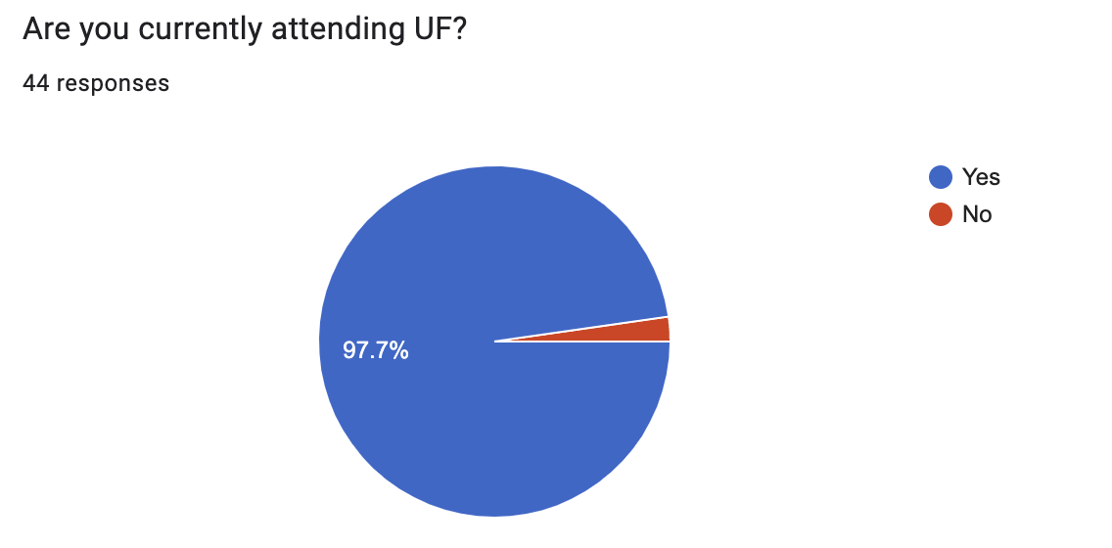
Results
Figure 1: Demonstrating 97.7% of our participants are currently UF students, with only 1 response not being part of UF nor a student. This data is crucial to take into account knowing that our app will be exclusively launched for University of Florida students.

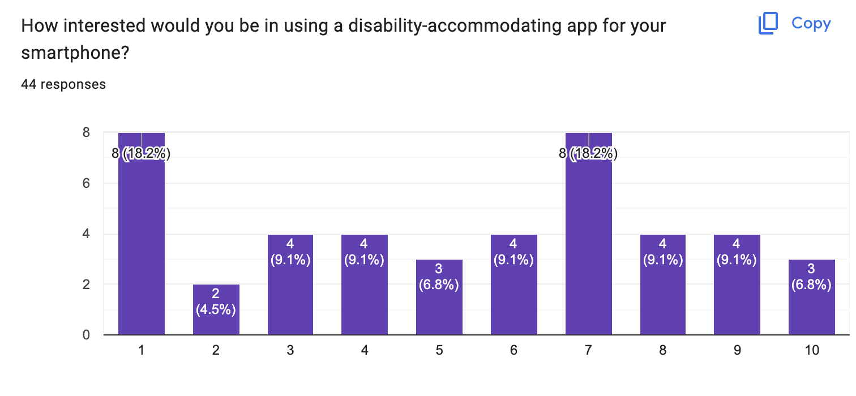
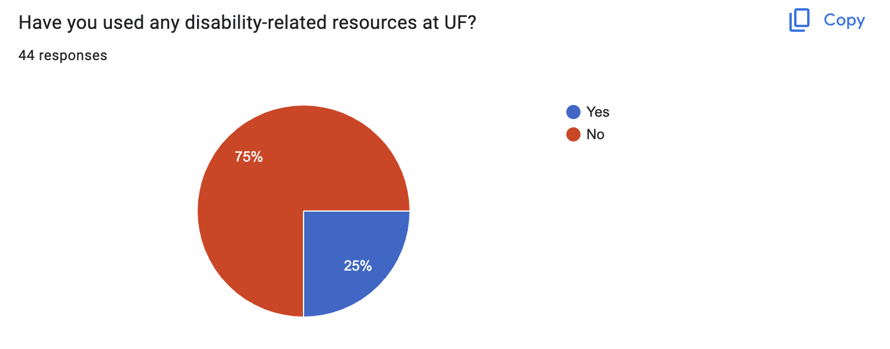
Figure 3: It is worth noting that 43.2% of responders expressed interest in using a disability-accommodating app for their smartphone, rating their interest level above 7 on a scale of 0 to 10.
Figure 2: Only ¼ of the responses we received had experience with using UF disability related resources. This suggests that our data may be more biased towards students not necessarily needing the resources we are trying to offer based on their past experiences.

From the responders, we've gathered a range of organizations and clubs deeply involved in the disability community. These groups, such as UF Disability Ambassadors, Disability Ambassadors, Delta Alpha Pi Honor Society, Disability Affairs Student Gov Cabinet, UF Special Olympics, and G.R.I.P. (Centering Engineering Technology for Disabled), could potentially be interested in supporting our app through sponsorship and contributing to its marketing efforts across campus.
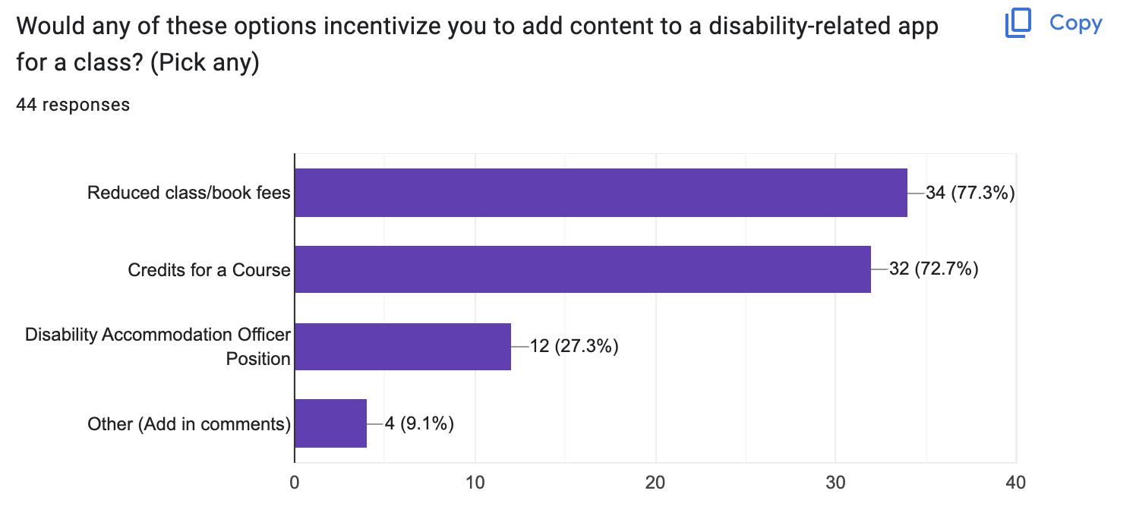
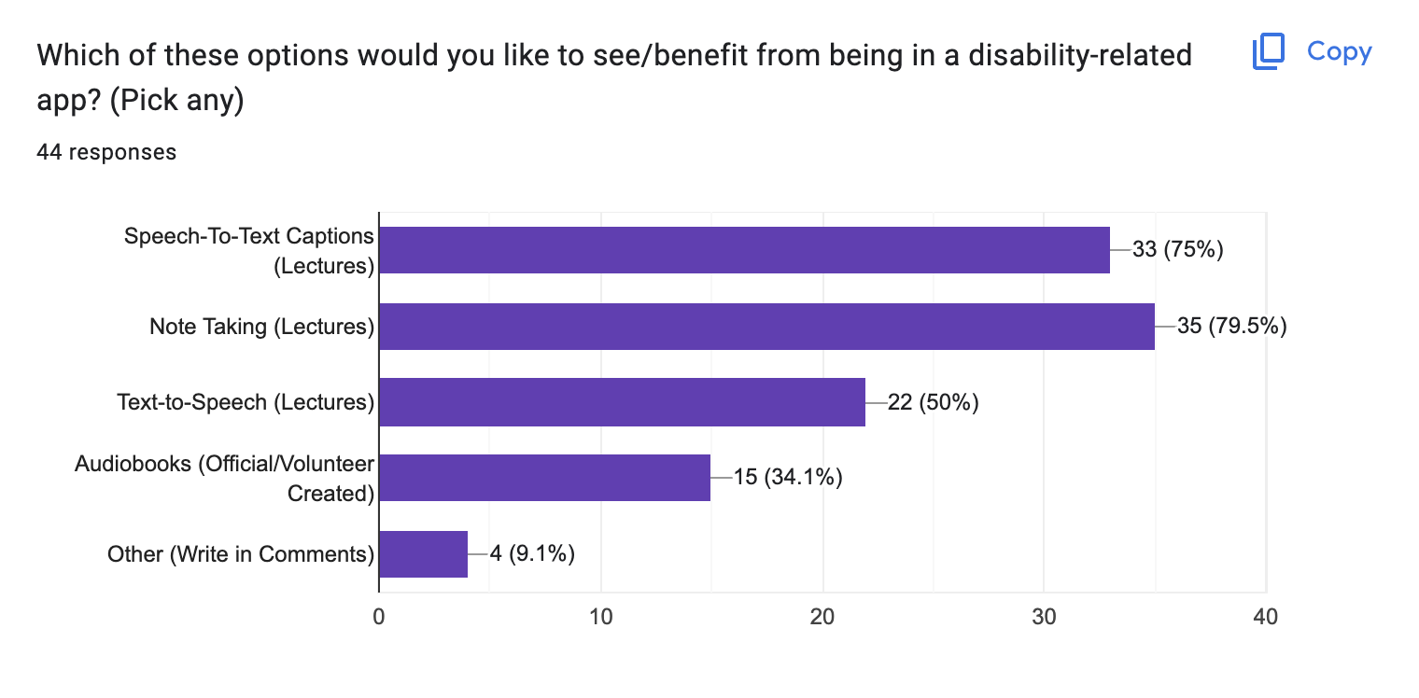
Additional comments suggest providing incentives like meal credits and opportunities for resume building, which are deemed more cost-effective. Additionally, offering volunteering hours as an incentive has been proposed.
Figure 5: This data shows the preferable incentives people would like to gain from volunteering in our disability-related app demonstrating large percentages in the reduction of class/book fees (34 votes with 77.3%) and receiving credits for a course (32 votes with 72.7%). With the data obtained, it is evident that a smartphone app would be possible with the correct incentives provided to the volunteers as well as the quality content uploaded to the platform would be used with the significant expressed interest in using such an app.
Figure 4: This data shows on the preferable options people would like to benefit from our disability-related app demonstrating a significant percentage in Speech-To-Text Captions (Lectures) and Note Taking (Lectures) with more than 75% of responders preferring those two options.

Discussion

There are a number of limitations to the study, including the relatively small sample size, of which only a quarter currently use disability accommodation resources at the University of Florida at all. Additionally, the survey was distributed exclusively through social media platforms, which could potentially skew the results compared to the general student body. Interest may also have been impacted if evidence were to be presented showing the effectiveness (or lack thereof) of smartphone applications in helping students with disabilities. However, it is noteworthy that 43.2% of responders expressed interest in using a disability-accommodating app for their smartphones, with a rating above 7 on a scale of 0 to 10. To address some of the limitations of the current system, in Figure 4, there are different features of the app that will be available to the user. The data in the figure reveals that many participants would benefit from Note Taking Lectures and speech to text captions in lectures to help improve their performance in classes.

Additionally, a significant percentage showed interest in contributing content as volunteers, with incentives such as reduced class/book fees (77.3%) and course credits (72.7%). Many respondents expressed a preference for incentives such as reduced education costs and education credits, which is worth considering. As we collaborate with UF, we can inquire directly with the school about implementing these incentives. A great incentive was also present to offer meal credits since it is a cost-effective option that could potentially bring more support from the University of Florida. The plan is to continuously survey throughout the lifespan of our app consistently to see how we could better improve the quality of life of our users and update it with the newest research and data for our targeted audience of the disability community.

With increased potential support from school organizations and/or clubs, we have the potential to bridge the gap between diverse learning styles and diminish the heightened risk of unemployment among individuals with disabilities. This risk often comes from the lack of integration of social inclusion and opportunities for economic self-sufficiency. [K] Additionally, the compounding effects of one or more chronic conditions on the health and functioning of over 80% of individuals with disabilities in the US can be alleviated through the use of our app, making their overall well-being smoother in university. [8]

Conclusion
Gaining insights from students at UF through surveys is vital for creating an app that meets their specific needs and preferences. By offering services such as speech-to-text captions, note-taking, text-to-speech, and audiobooks, we can effectively cater to their requirements. It is essential to address the barriers faced by around 15% of the global population in accessing education and achieving economic independence, as this has significant implications for their rights and a country's welfare. By understanding people's needs and bridging any current gaps, we can develop a product that truly benefits the student community. Furthermore, finding student organizations interested in sponsoring or using our app enhances the value of our research. Students should have the liberty to use all the resources available to them according to the usability/accessibility, flexibility/adaptability (freedom of customization) and ability to use it on your mobile devices, since it is very commonly used and can be easily used in any classroom as many other great companies have done. [9] We could cater to our students in the University of Florida.

Technical Plan
Our team’s objective is to design and implement a mobile application that will suit the needs of students with disabilities and allow them to better perform in an academic environment. The research idea was pitched and approved by everyone on the team, and right after deciding on the topic, a disability resource accommodations application for UF students, we began to figure out the best resources to include in the app. Speech-to-text captions, Note-taking, Text-to-speech, and Audiobooks were the proposed resources. We also proposed Reduced class/book fees, Credits for a course, and a Disability Accommodation Officer position as incentives for people to work on the app. The group saw a need to determine which resources and incentives would be best to focus on for the application. We created a survey that was distributed to UF students, to help us answer those questions. The group researched literature relating to our topic to determine the benefits of the app and examples of similar technologies already implemented. We concluded that an online app would be just as beneficial as physical resources with the added bonus of being easily accessible and free. The survey was closed after 44 people had answered and the results were analyzed by the group, which allowed us to calculate the level of interest that students had in the app and what they wanted from it. We found that respondents were interested in and wanted class notes and speech-to-text captions. Reduced class/book fees or credits for a course were the main incentives requested.
After establishing a team: A number of employees will be necessary to create, maintain, and modify the application as needed, including a product manager, UX/UI designer, mobile developer, quality assurance analyst and digital marketer. An outline of a user interface (UI) will be drawn up by a UX designer, developing a mockup template to create a format of what is expected from the app, such as its format and design. In order to ensure security, we intend to implement encrypted data, authorized APIs, strong authentication, tamper-detection software, and consistent testing for potential breaches. After initial completion of the app, tests of all of its features, settings, and pages will be done to see if there are any errors that can found before final release. Additionally, front-end and back-end functionality, device compatibility, app integration, application type, installation and storage, and security optimization will be taken into account. The app will then be loaded with the correct initial resources and a group of volunteers will be gathered to put their content into the application to test the code's functionality. As the app is released to the public, it is imperative to continue receiving feedback from users to make necessary updates and adjustments.
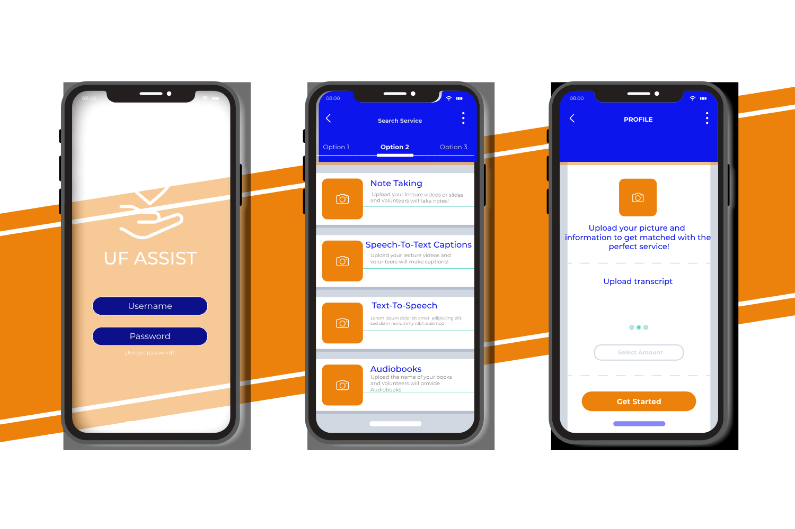
Figure 6: Mock-Up of potential app design
This application will be published to both the Android Google Play Store and iOS Apple App Store. To meet the common requirements of both platforms, the application will need an icon, images, and description that showcase the functionality. The graphic designer working on this aspect has to account for the various disabilities of the target audience while making these graphics. The application also has to be made searchable using keywords and optimized metadata, so that students can find it easily if they search for it. The application also needs an age rating, as it is for college students specifically. For both stores, accounts need to be made. For iOS, the application needs to be made using Xcode and App Store Connect is used to manage the application’s listing, build uploads, and track performance. For Android, Android Studio needs to be used to make the application, and its listings can be managed by Google Play Console. In all cases, the application needs to be tested for compatibility across devices of different screen sizes and resolutions. Privacy is also a huge concern for both stores, so the application should have a clear policy and transparency regarding what information it is accessing. The app may need to request users for access to their camera roll in order to upload video or image content into the app. The user may also upload sensitive information regarding their disability in order to get the most accurate service. To protect this information, adequate security measures are needed.
Maintenance of the app will primarily focus on important updates, fixing bugs, and improving mobile app architecture and functionality. It will integrate maintaining the compatibility of the app with changing operating systems and devices. Security updates will be necessary as technology evolves, and app stores maintain stringent quality guidelines and may reject an app that does not perform consistent maintenance to meet such requirements. This also has the added benefit of giving access to the latest smartphone features while improving the app’s security and stability over time.
For volunteers, we intend to provide information about regional accessibility guidelines and standards to ensure that volunteers are aware of and adhere to specific accommodations required in their area. Additionally, we would like to forge partnerships with local disability advocacy groups and organizations that support disabled individuals at UF. Leveraging these partnerships can enhance the app's reach and effectiveness in specific locations and spread awareness of its capabilities to those who can best utilize it.
There are a number of challenges that we anticipate facing. Long-term maintenance and retention of key employees for app development can be expensive and take a large portion of the application’s budget. Cybersecurity problems and bugs can hinder the app’s effectiveness for a period of time before updates and fixes are implemented. The app may not work efficiently for all of its intended users, impacting its retention rate. One potential solution to these concerns may be outsourcing some of the costs to a local company.

Budget & Schedule

Budget
According to the severity of disability, there have been links to their wellbeing and poverty. By creating an app, which helps to provide services with easier and cheaper accessibility provided with a large grant to keep the app operational for a longer period of time in order for students with disability to lower the cost of college overall. People with disabilities tend to have additional costs which can be influenced by factors such as the person’s impairment, available resources and the accessibility and prices of goods and services in their environment [10]. The base amount to make this app would cost $200,000. However, in order to maintain it, it would cost around $25,000 annually to maintain it. The increase considers the app’s complexity with syncing with the Internet, processing in-app purchases, using real-time GPS, push notifications, or linking with other users [11]. In addition to coding, we have to consider design costs, back-end development, security, architecture, and testing. This calculation of money would be with the mind using at least the minimum amount of $500,000, which would help us to maintain the app for more than eight years considering cost of technology advancement increasing cost over time [12].

Schedule
- November 26th: Recruit coders to the team.
- November 26th: Decide on the layout after brainstorming together.
- November 28th: Complete a mockup of the app, and test consistently for adjustments and corrections.
- November 30th: Complete a security program for the app, while continuously being tested.
- December 1st: Completion of the code’s app.
- December 2nd: Volunteers must add their content to see to test if this section of the code works for the volunteer's input.
- December 2nd - December 4th: Gather feedback from selected users and modify with more specific issues.
- December 4th: Finalize the budget.
- December 6th: Turn in Proposal Project and launch of the Project.

Evaluation Plan
The goal of our proposal is to develop an app that suits the needs of those with disabilities and allows them to perform better in an academic environment. In order to see if the app is performing its intended function, there are several tests that can be conducted:

Test for GPA Increases
To test the main purpose of the application, changes in the students’ performance in classes will be monitored. Initially when they install the app, their current grades will be recorded. After one semester of using the app, their latest grades will be recorded and compared with the initial grades. To figure out whether or not the application had a noticeable impact on their academic scores, the user would be asked whether they thought the application had an impact on their study routine in the past semester, and the differences in difficulty between the courses they took previously and currently. Our primary achievement would be enhancing our users' academic performance, benefiting not only the students but also the entire university community as a whole.

Overall Usage of App
In order to determine the effectiveness of the app, one key metric is how many students that use disability services elect to install the application, and how often they engage with it to perform their coursework. If both registered students and volunteers regularly check in with the application to use its features, there is a clear indicator that the app is serving an important role in their college education.

Number of Volunteers
The app will rely heavily on the content that students create and provide for others to use. Because of this dependence on volunteer input, it is important to monitor the amount of people providing resources to the app to determine the quantity and quality of the materials available and ensure that they are acceptable. To do so we will collect data on the number of volunteers at the middle and end of each semester to maintain a constant flow of resources into the app. We will also survey the users once per semester and ask for their satisfaction with the resources in general, to determine the quality and relevance of the material provided by volunteers.

User Engagement with App
An overall analysis would be useful to understand user’s engagement and to gain more feedback over the reasoning to quantity (whether high or low) of retention rate and session durations. By asking questions through survey, we could collect this data and ask if whether the users’ perceptions of how the app has affected their academic performances or eased the difficulty of their courses. Technical inquiries are equally important to address potential glitches, bugs, or malfunctions experienced while utilizing the app. Understanding its reliability, functionality, and any encountered bugs will aid in refining the app's performance. Essentially, our goal is to understand users' experiences and continuously improve the app to meet the changing needs of students with disabilities.

Dissatisfaction/Satisfaction with the App
To collect information about the different features of the app including content and accessibility, it is necessary to evaluate satisfaction among users of the app. Through a survey, a variety of questions will assess user satisfaction with the content that is being uploaded, asking for their input on the relevance of the content and if they would prefer to see different content being uploaded. Additionally, to evaluate technical aspects of the app, the survey would include questions on if the user has experienced difficulties with loading times, visual glitches, typos, and any other issues that impact the overall purpose of the app.

References
[1] L. Aron and P. Loprest. "Disability and the education system." The Future of Children, Vol. 22, Issue 1, 2012
[2] J.Blasey et al. (2023). "Accommodation Use and Academic Outcomes for College Students With Disabilities." Psychological Reports, 126(4), March 18, 2022.
[3] J. M. Carroll et al. “Barriers to Bachelor’s Degree Completion among College Students with a Disability,” Sociological Perspectives, vol. 63, no. 5, pp. 809–832, Mar. 2020.
[4] “Disability Resource Center,” Disability. https://disability.ufl.edu/
[5] S. Bandyopadhyay, B. B. Rathod, "The Sound and Feel of Titrations: A smartphone Aid for Color-Blind and Visually Impaired Students", Journal of Chemical Education, vol. 94, no. 7, pp. 946-949, Jun. 5, 2017, doi: http://dx.doi.org/10.1021/acs.jchemed.7b00027
‌[6] C. Mead et al., “A comparative case study of the accommodation of students with disabilities in online and in-person degree programs,” PLOS ONE, vol. 18, no. 10, pp. e0288748–e0288748, Oct. 2023, doi: https://doi.org/10.1371/journal.pone.0288748.
[7] W. H. Kim and J. Lee, “The Effect of Accommodation on Academic Performance of College Students With Disabilities,” Rehabilitation Counseling Bulletin, vol. 60, no. 1, pp. 40–50, Aug. 2016, doi: https://doi.org/10.1177/0034355215605259.
[8] M. Jones, J. Morris, and F. Deruyter, “Mobile Healthcare and people with disabilities: Current State and future needs,” International Journal of Environmental Research and Public Health, vol. 15, no. 3, p. 515, 2018. doi:10.3390/ijerph15030515
[9] J. Ismaili and E. H. Ibrahimi, “Mobile learning as alternative to assistive technology devices for special needs students,” Education and Information Technologies, vol. 22, no. 3, pp. 883–899, 2016. doi:10.1007/s10639-015-9462-9
[10] S. Mitra, M. Palmer, H. Kim, D. Mont, and N. Groce, “Extra costs of living with a disability: A review and agenda for research,” Disability and Health Journal, vol. 10, no. 4, pp. 475–484, 2017. doi:10.1016/j.dhjo.2017.04.007
[11] “App Maintenance Cost in 2023: How much does it cost to maintain an app?,” Ailoitte Blog, https://www.ailoitte.com/blog/how-much-does-it-cost-to-maintain-an-app/#:~:text=The%20cost%20to%20maintain%20the,20%%20of%20the%20initial%20cost. (accessed Oct. 18, 2023).
[12] “How much does it cost to make an app for business in 2023,” Addevice, https://www.addevice.io/blog/how-much-does-it-cost-to-build-a-mobile-app#:~:text=App%20Maintenance%20Costs&text=The%20app%20maintenance%20may%20cost,Outsystems%2C%202018-2019). (accessed Oct. 18, 2023).

